Installation Material UI

Go to this link -> <https://mui.com/material-ui/>

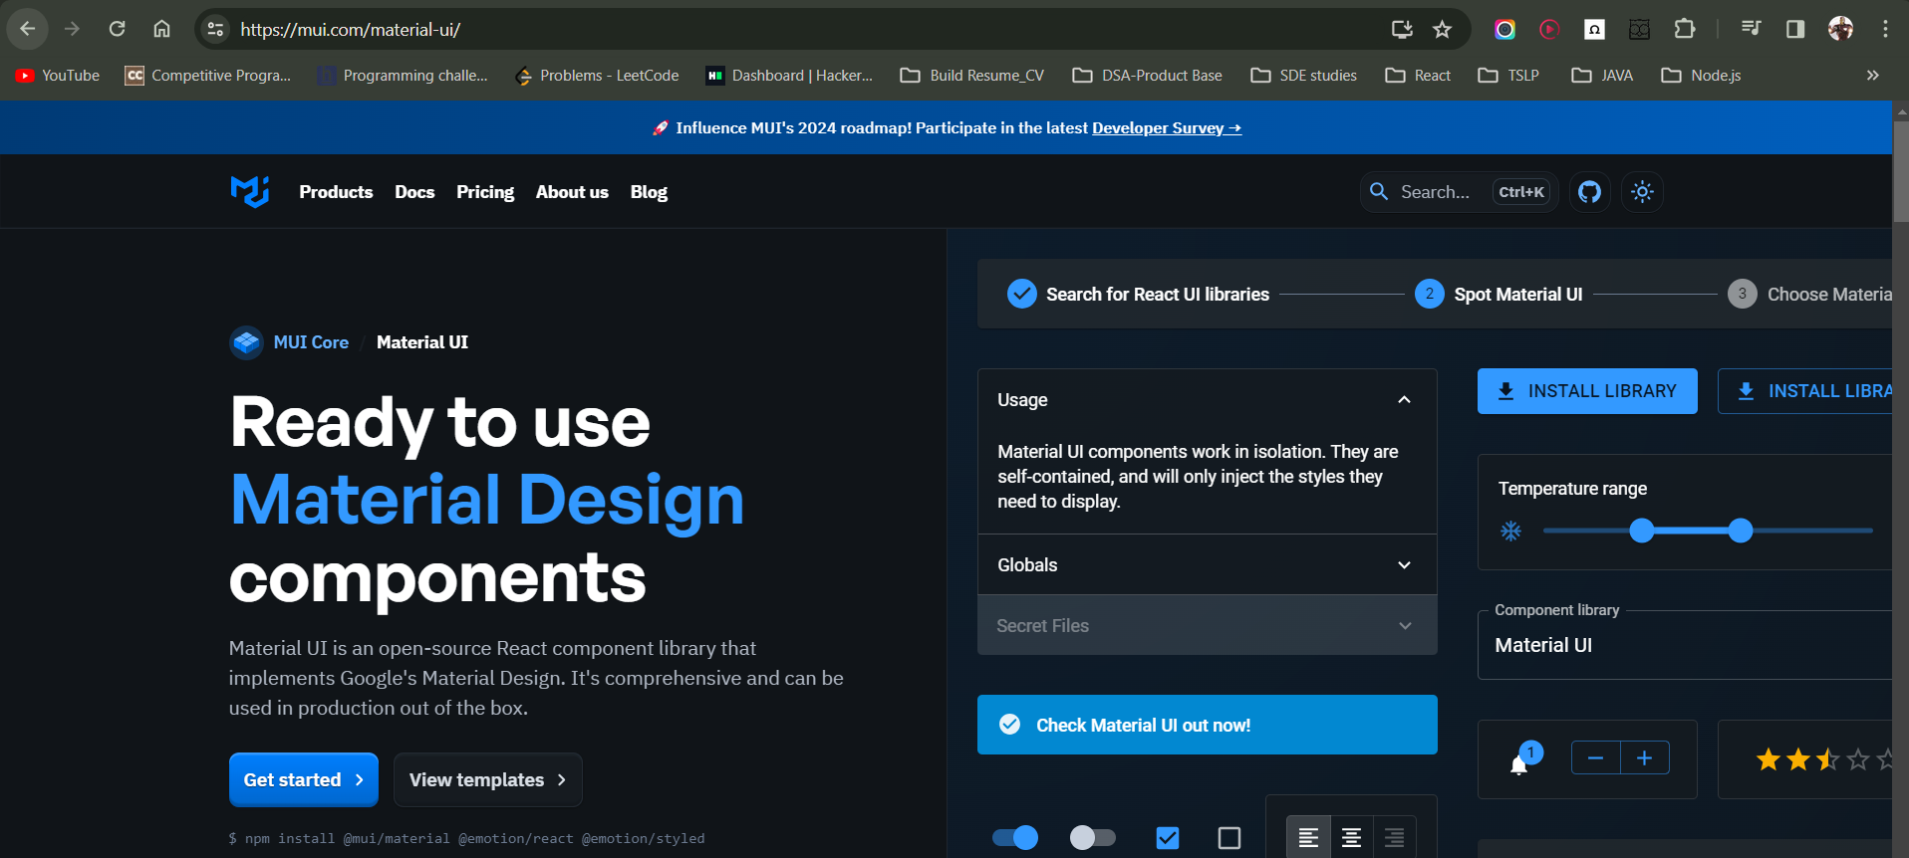

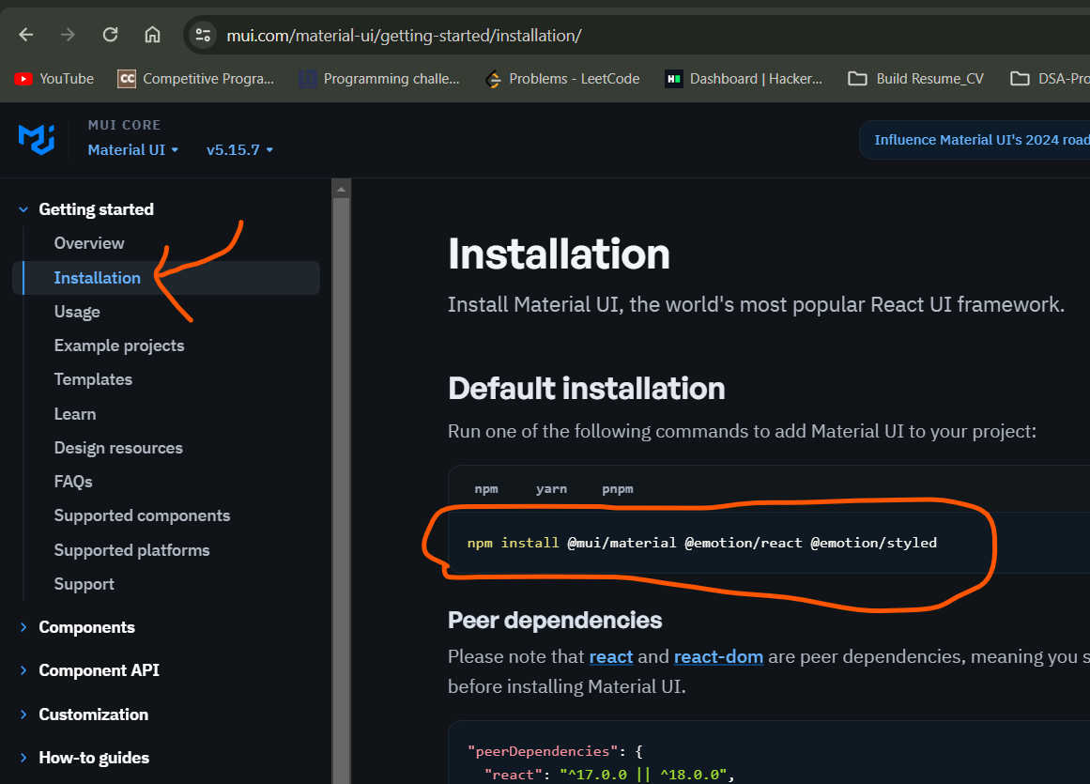

Cmd to install -> npm install @mui/material @emotion/react @emotion/styled

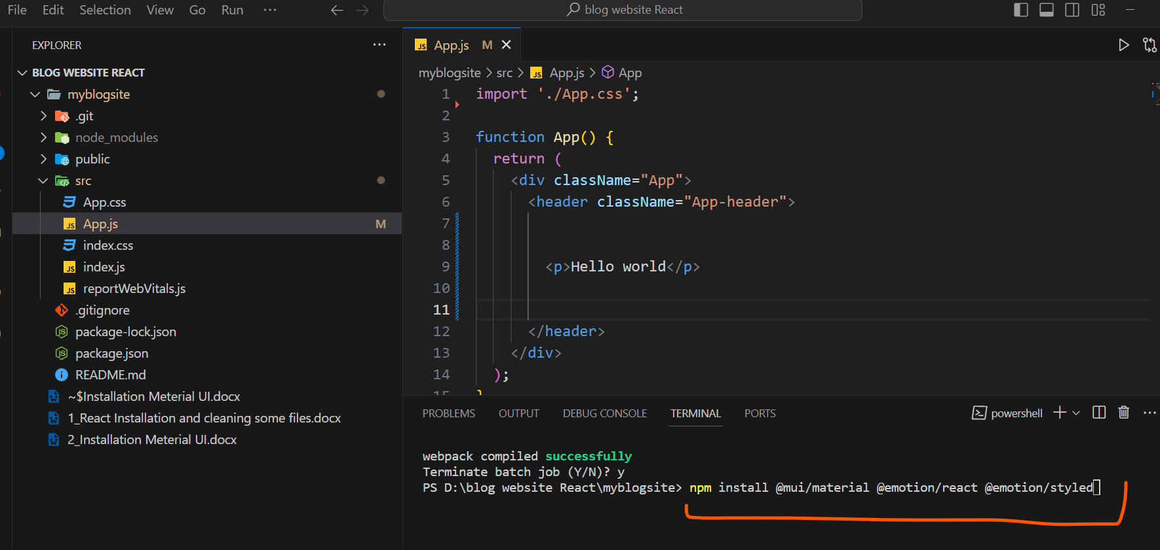

Once installation done, check is it installed or not

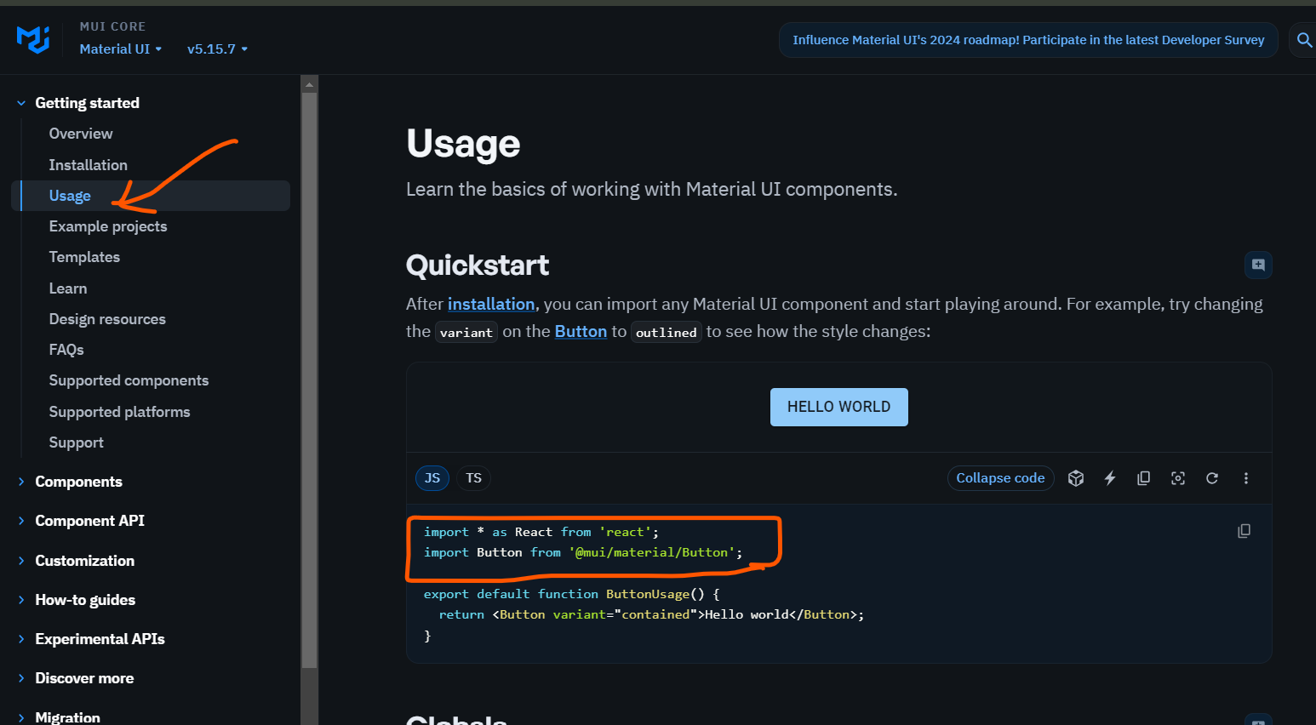

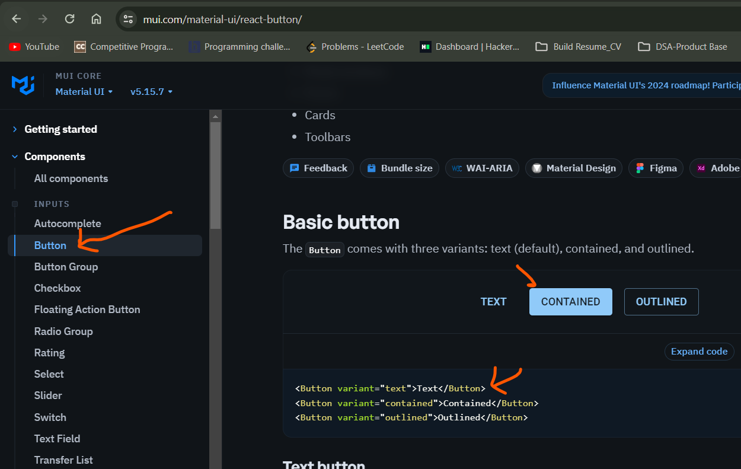

Pasted in VS code,

App.js

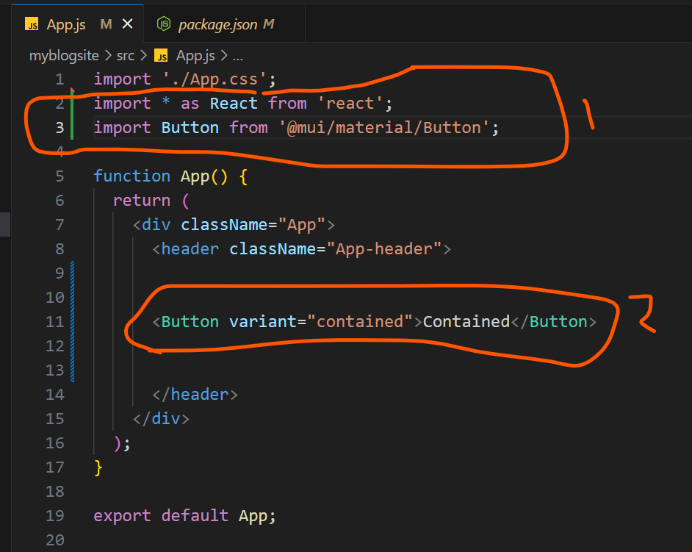

Check in the browser

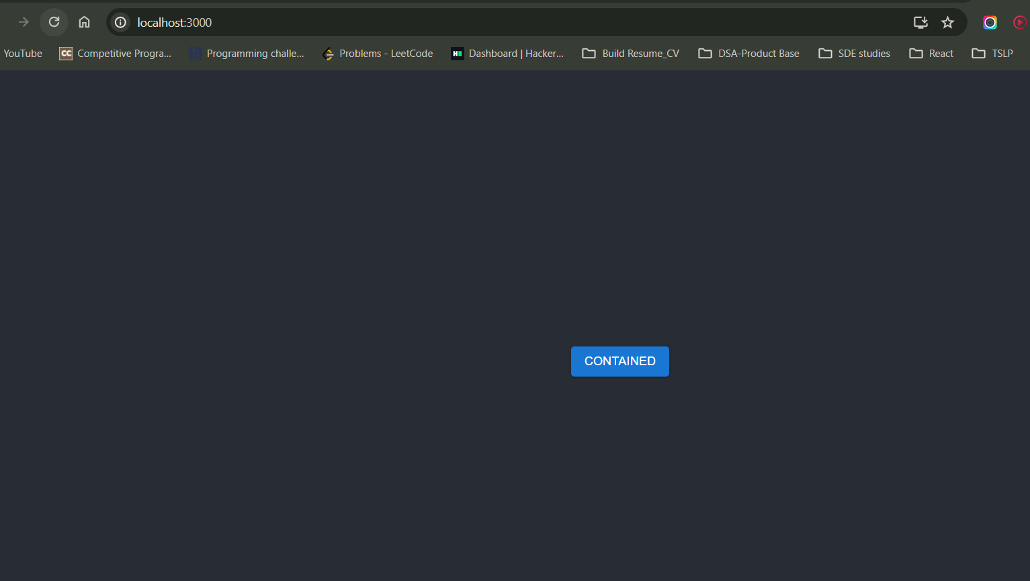

It is working

2nd is Installation of Material UI Icons

Copy and paste it to VS code terminal

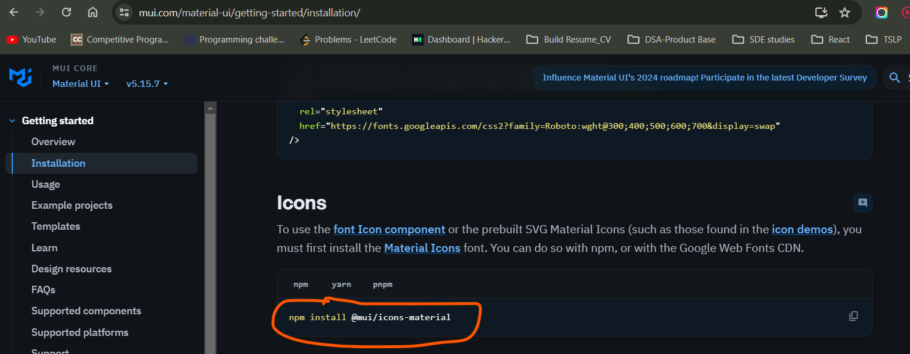

Once Icon installation done

Import and check

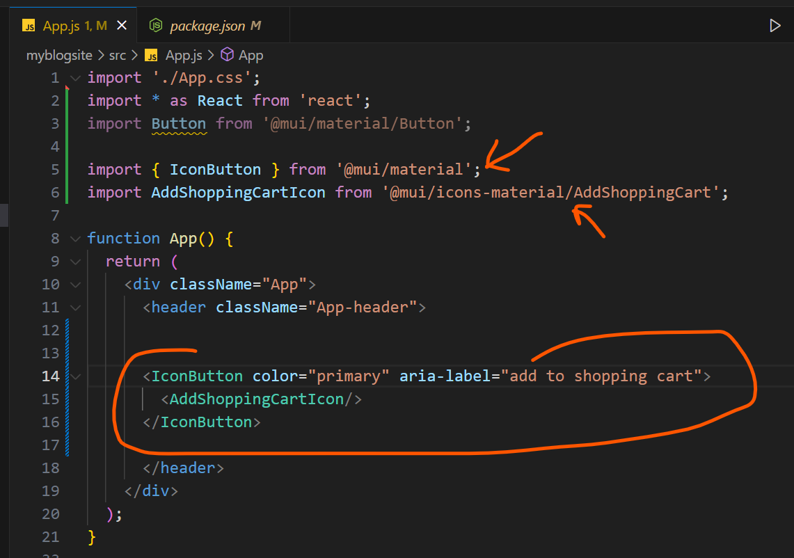

Check in the browser

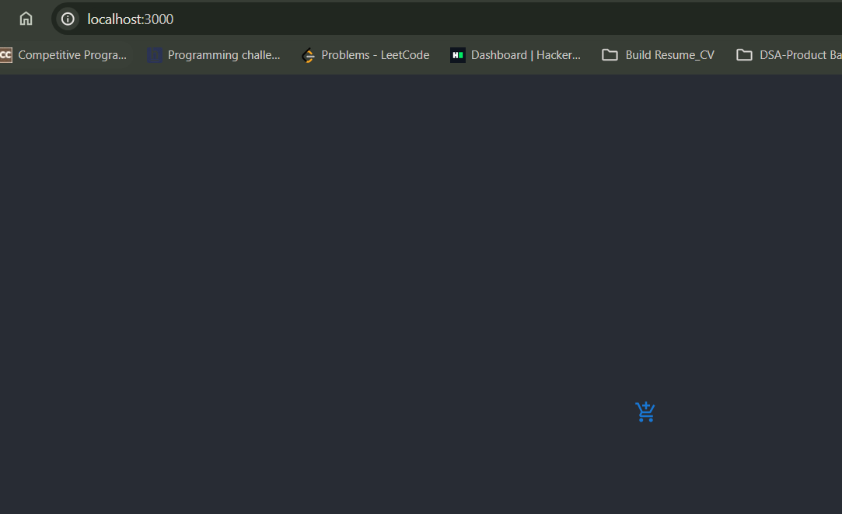

========================end==================